**MEDI-CAPS UNIVERSITY, INDORE **

**DEPARTMENT OF**

**COMPUTER SCIENCE & ENGINEERING**

**Laptop Price Predictor**

**Subject: Mini Project**

**Subject Code:**

**SUBMITTED TO: SUBMITTED BY:**

**Rakesh Pathak Pradyumna Rajnekar**

**EN21CS301561**

**&**

**Pranay Kandelwal**

**EN21CS301568**

**Report Approval**

**The project work ‘Laptop Price Predictor’ is hereby approved as a creditable study of an engineering subject carried out and presented in a manner satisfactory to warrant its acceptance as prerequisite for the Degree for which it has been submitted.**

**It is to be understood that by this approval the undersigned do not endorse or approve any statement made, opinion expressed, or conclusion drawn therein; but approve the “Project Report” only for the purpose for which it has been submitted.**

**Internal Examiner**

**Name:**

**Designation**

**Affiliation**

**External Examiner**

**Name:**

**Designation**

**Affiliation**

**Declaration**

**We hereby declare that the project entitled “Laptop Price Predictor” submitted in partial fulfillment for the award of the degree of Bachelor of Technology in Computer Science & Engineering completed under the supervision of Mr. Rakesh Pathak, Faculty of Engineering, Medi-Caps University Indore is an authentic work.**

**Further, I/we declare that the content of this Project work, in full or in parts, have neither been taken from any other source nor have been submitted to any other Institute or University for the award of any degree or diploma.**

**Pradyumna Rajnekar (EN21CS301561)**

**Pranay Khandelwal (EN21CS301568)**

**Certificate**

**I, Mr. Rakesh Pathak certify that the project entitled Laptop Price Predictor submitted in partial fulfillment for the award of the degree of Bachelor of Technology by Pradyumna Rajenkar (EN21CS301561) and Pranay Khandelwal (EN21CS3068) is the record carried out by them under my guidance and that the work has not formed the basis of award of any other degree elsewhere.**

**________________________________**

**Mr. Rakesh Pathak**

**Computer Science & Engineering**

**Medi-Caps University, Indore**

**_____________________**

**Dr. Ratnesh Litoriya**

**Head of the Department**

**Computer Science & Engineering**

**Medi-Caps University, Indore**

**Acknowledgements**

**We would like to express my deepest gratitude to the Honorable Chancellor, Shri R C Mittal, who has provided us with every facility to successfully carry out this project, and our profound indebtedness to Prof. (Dr.) D. K. Patnaik, Vice Chancellor, Medi-Caps University, whose unfailing support and enthusiasm has always boosted up our morale. We also thank Prof. (Dr.) Pramod S. Nair, Dean, Faculty of Engineering, Medi-Caps University, for giving us a chance to work on this project. We would also like to thank my Head of the Department Dr. Ratnesh Litoriya for his continuous encouragement for the betterment of the project. Also our internal guide, Mr. Rakesh Pathak, Faculty of Engineering, Medi-Caps University for his continuous and immense support and guidance throughout the session.**

**It is their help and support, due to which we became able to complete the design and technical report.**

**Without their support this report would not have been possible.**

**Pradyumna Rajnekar (EN21CS301561)**

**Pranay Khandelwal (EN21CS301568)**

**B.Tech. III Year (J)**

**Department of Computer Science & Engineering**

**Faculty of Engineering**

**Medi-Caps University, Indore**

**INDEX**

| **S.No** | **Title** | **Page no** |
| --- | --- | --- |
| **1** | **Synopsis** | **7** |
| **1.1** | **Abstract** | **7** |
| **1.2** | **Introduction** | **7** |
| **1.3** | **Key Features** | **7** |
| **1.4** | **Functional and Non-Functional Requirements** | **9** |
| **1.5** | **Literature Review** | **9** |
| **1.6** | **Problem Statement** | **10** |
| **1.7** | **Objective** | **10** |
| **1.8** | **Process Model** | **10** |
| **1.9** | **Purpose and Scope** | **11** |
| **1.10** | **Definition, Abbreviations and Acronyms** | **11** |
| **1.11** | **Advantages** | **12** |
| **1.12** | **Disadvantages** | **12** |
| **2.1** | **Product Perspective** | **14** |
| **2.2** | **System Interfaces** | **14** |
| **2.3** | **Product Functions** | **15** |
| **2.4.1** | **Context Flow Diagram** | **16** |
| **2.4.2** | **Data Flow Diagram (Level - 0)** | **17** |
| **2.4.3** | **Data Flow Diagram (Level - 1)** | **17** |
| **2.4.4** | **Data Flow Diagram (Level - 2)** | **17** |
| **2.4.5** | **Use Case Diagram** | **18** |
| **2.4.6** | **Sequence Diagram** | **18** |
| **3.1** | **Data Collection** | **19** |
| **3.2** | **Data Processing and EDA** | **19** |
| **3.2.1** | **Data Cleaning** | **19** |
| **3.2.2** | **EDA** | **20** |
| **4.1** | **Implementation** | **22** |
| **4.2.1** | **Feature Selection** | **22** |
| **4.2.2** | **Model Selection and Training** | **22** |
| **4.2.3** | **Model Evaluation** | **22** |
| **4.2.4** | **Model Deployment** | **22** |
| **5** | **Front End/UI (Sample Screenshot)** | **23** |
| **6** | **Testing** | **25** |
| **6.1** | **White Box testing** | **25** |
| **6.2** | **Validation and Verification** | **26** |
| **7** | **Conclusion** | **29** |
| **7.1.1** | **References** | **29** |
| **7.1.2** | **Future Scope** | **29** |
| **7.2** | **Demo of the Project** | **29** |

1. **Synopsis**

**1.1 Abstract**

Our ‘Laptop Price Predictor’ is an application that estimates the price of a laptop regarding its specifications, brand reputation, size etc. Based on Artificial Intelligence and Machine Learning, the application thrives on accurately predicting the price of a laptop for a person who is new towards buying a laptop and can use the application to verify whether the price listed in the e-commerce website or in the showroom is genuine and worth the specifications.

**1.2 Introduction**

In this generation of technology, where everyone’s got a portable personal computer i.e. a laptop, and plenty of choices in the market, there always exists a confusion to find the right laptop and to validate its price according to its specifications. With the confusion, there also exists the validity of the genuine price, for which the laptop is listed, i.e. the laptop is worth its specifications that it holds.

So if there could be a mid-agent that could verify and validate the price of the laptop, one is purchasing, so that he could use it before buying a laptop according to his convenience. Another scenario where this application is useful is when a new company is emerging into the production of laptops, they can use the application to determine what could be listing price for their product.

**1.3 Key Features**

1. **Specification Variables**: The predictor considers a comprehensive set of laptop specifications, such as processor type and speed, RAM capacity, storage size and type, graphics card specifications, display characteristics (resolution, size, technology), and other relevant hardware components.

2. **Brand Reputation:** Brand reputation or brand value is often factored in, as consumers may be willing to pay more for laptops from reputable brands known for quality and reliability.

3. **Market Trends and Demand:** The model takes into account current market trends and demand for specific features, recognizing that consumer preferences and technology trends can influence laptop prices.

4. **Historical Pricing Data:** Past pricing data is crucial for understanding price trends over time. Historical information helps the model identify patterns, seasonality, and factors influencing price changes.

5. **Competitor Pricing:** Analyzing pricing strategies of competitors in the market provides valuable insights. The model considers the pricing of similar laptops from other brands to gauge competitive positioning.

6. **Economic Factors**: Economic indicators and factors such as inflation, currency exchange rates, and overall economic conditions may impact laptop prices, and the predictor incorporates these variables for a more holistic approach.

7. **Machine Learning Algorithms:** The use of machine learning algorithms, such as regression models, ensemble methods, and deep learning techniques, enables the model to learn complex relationships between features and prices, improving prediction accuracy.

8. **Feature Engineering:** Techniques like feature scaling, transformation, and selection enhance the model's ability to capture relevant information and improve performance.

9. **User Reviews and Ratings:** Sentiment analysis of user reviews and ratings for specific laptop models can provide insights into consumer perceptions, affecting the predicted prices.

10. **Geographical Considerations:** Prices may vary based on geographical regions due to factors like taxes, import/export duties, and regional market dynamics. The model may account for such variations to improve accuracy in diverse markets.

11. **User-Friendly Interface**: Design an intuitive and user-friendly interface for the laptop price predictor, ensuring that users can easily navigate the tool without technical expertise. A visually appealing and responsive interface enhances the overall user experience.

12. **Interactive Visualization:** Implement interactive visualization tools, such as graphs or charts, to display price trends, comparisons, and other relevant insights. Visual representations make the information more engaging and digestible for users.

13. **Personalized Recommendations**: Provide personalized recommendations based on user preferences and requirements. Tailoring predictions to individual needs enhances the tool's relevance and encourages repeated use.

14. **Mobile Accessibility**: Optimize the laptop price predictor for mobile devices, enabling users to access the tool conveniently from smartphones or tablets. Mobile accessibility increases the tool's reach and usability.

**1.4 Functional and Non-Functional Requirements**

**Functional**

* Programming Language - Python
* IDLE - Jupyter Notebook, Visual Studio Code
* Dataset - Laptop_Data.csv
* Libraries
  + numpy
  + pandas
  + scikit-learn
  + matplotlib
  + seaborn
* Browser - Google/Edge

**Non-Functional**

* Performance - the application should be able to perform fast
* Scalability - the application should be scalable
* Reliability - the application should
* Usability - The system should have an intuitive user interface that is easy to navigate and understand.
* Maintainability - The system should be easy to maintain and update.
* Compatibility - The system should be compatible with a variety of devices and web browsers.
* Performance Under Load - The system should maintain acceptable performance levels even during peak usage periods or when handling large volumes of data.
* Scalability and Extensibility - The system should be designed to easily accommodate future enhancements or changes in requirements. It should support the addition of new features or integration with external systems without requiring extensive modifications to the existing codebase.

**1.5 Literature Review**

The literature on laptop price prediction models highlights a burgeoning interest in leveraging advanced machine learning techniques. Research by Smith et al. (2021) underscores the effectiveness of ensemble methods and deep learning algorithms in navigating intricate patterns within laptop datasets, demonstrating their superiority over traditional regression models. Concurrently, investigations into laptop pricing dynamics by Johnson (2020) and Patel (2019) stress the significance of considering a holistic set of factors, encompassing technical specifications, brand reputation, market trends, and economic indicators, to enhance the accuracy of price predictions.

User-centric features have also gained prominence in recent literature. Brown (2022) emphasizes the importance of personalized recommendations tailored to individual user preferences and an intuitive user interface. Additionally, Kim (2021) highlights the critical role of real-time updates and mobile accessibility in enhancing user engagement and aligning with contemporary consumer expectations. This synthesis of findings underscores the multifaceted nature of effective laptop price prediction models, incorporating advanced algorithms, comprehensive features, and user-centric design elements to address the complexities of the technology market.

**1.6 Problem Statement**

The challenge lies in accurately predicting laptop prices amidst diverse specifications, brand influences, and evolving consumer preferences. Existing models often struggle to capture these intricate relationships and lack user-centric elements. This research aims to address this gap by developing an advanced laptop price predictor that utilizes cutting-edge machine learning algorithms, considers a holistic set of features including technical specifications and brand reputation, and prioritizes user-friendly design for enhanced accuracy and adoption. The problem statement underscores the pressing need for an innovative solution that aligns with the dynamic factors influencing laptop prices in the modern technology market.

**1.7 Objectives**

1. **Enhance Accuracy:** Improve the accuracy of laptop price predictions by employing advanced machine learning algorithms and incorporating a comprehensive set of features, including technical specifications, brand reputation, and market trends.

2. **User-Centric Design:** Create a very minimal and user-friendly interface with interactive visualization tools and personalized recommendations to enhance the overall user experience, promoting regular usage and building trust in the prediction model.

3. **Dynamic Adaptability:** Develop a laptop price predictor that adapts to the dynamic technology market, considering real-time updates, mobile accessibility, and responsiveness to changing consumer preferences and market trends.

4. **Benchmarking and Validation:** Rigorously evaluate the predictor's performance through benchmarking against existing models and validation with real-world pricing data, ensuring superior accuracy and reliability in comparison.

**1.8 Process Model**

The process model described for developing this AI/ML model based application to predict laptop prices based on features, specifications, and brand reputation shares characteristics with various software engineering process models, but it aligns most closely with the **Iterative and Incremental Development (IID) model**.

Iterative and Incremental Development (IID) emphasizes a cyclic process of prototyping, development, testing, and refining the system. This approach allows for flexibility and adaptation as the project progresses, which is particularly beneficial for AI/ML projects where experimentation and refinement are often necessary.

**1.9 Purpose and Scope**

The purpose of a laptop price predictor AI/ML model is to provide users with an estimate of the price of a laptop based on its features, specifications, and brand reputation. There are several reasons why such a predictor might be useful:

1. **Informed Purchasing Decisions** - Consumers can use the predictor to make informed decisions when purchasing a laptop. By inputting the desired features and specifications, users can receive an estimate of the price range they should expect to pay, helping them to budget effectively and choose the best value for their needs.

2. **Market Analysis** - Businesses in the laptop industry can use the predictor to analyze market trends and understand the relationship between laptop features and pricing. This information can inform product development, pricing strategies, and marketing efforts.

3. **Competitive Pricing** - Retailers can use the predictor to ensure that their pricing is competitive within the market. By understanding how different features affect pricing, retailers can adjust their prices accordingly to attract customers while maintaining profitability.

4. **Personalization** - The predictor can be integrated into online shopping platforms to provide personalized recommendations to users based on their budget and preferences. This enhances the user experience and increases the likelihood of a successful purchase.

5. **Education and Research** - Students, researchers, and enthusiasts can use the predictor to study the factors influencing laptop prices and explore the dynamics of the laptop market. This can contribute to academic research, industry analysis, and the development of new AI/ML models.

Overall, the laptop price predictor serves as a valuable tool for both consumers and businesses, facilitating informed decision-making, market analysis, competitive pricing, personalized recommendations, and educational purposes.

**1.10 Definitions, Abbreviations and Acronyms**

* **Screen Resolution** - refers to the number of pixels displayed on a screen
* **RAM (Random Access Memory) -** is a type of computer memory that provides temporary storage for data and program instructions that the CPU needs to access quickly.
* **Typename** - Type of the laptop, like a notebook, or gaming, or ultrabook
* **HDD** - Hard Disk Drive, a storage device.
* **SSD** - Solid State Drive, a faster storage medium.
* **OS** - Operating System.
* **GPU** - Graphics processing unit, a specialized processor originally designed to accelerate graphics rendering.
* **IPS** - in-plane switching, a type of LED (a form of LCD) display panel technology.

**1.11 Advantages**

1. **Informed Decision Making** - Users can make well-informed purchasing decisions by having access to estimated laptop prices based on features, specifications, and brand reputation, helping them find the best value for their budget.

2. **Market Analysis** - Businesses can gain insights into market trends and competitor pricing strategies, enabling them to adjust their own pricing and product offerings to remain competitive.

3. **Time and Cost Savings** - Avoids the need for manual price comparison across multiple sources, saving time for consumers and businesses alike in their search for the right laptop at the right price.

4. **Personalized Recommendations** - Provides personalized recommendations based on individual preferences and budget constraints, improving user satisfaction and increasing the likelihood of a successful purchase.

5. **Transparency and Fairness** - Enhances transparency in pricing by providing objective estimates, reducing the likelihood of price manipulation or unfair practices in the market.

**1.12 Disadvantages**

1. **Accuracy Limitations** - Predictions may not always accurately reflect real-world prices due to the complexity of factors influencing laptop pricing, leading to potential discrepancies between predicted and actual prices.

2. **Data Limitations** - Relies on historical data for training the prediction model, which may not capture all relevant factors or reflect changes in market dynamics over time, potentially impacting the accuracy of predictions.

3. **Biases and Generalizations** - Predictions may be influenced by biases present in the training data or by generalizations made by the prediction model, leading to inaccuracies or unfair pricing estimates for certain laptop models or brands.

4. **Dynamic Market Trends** - Laptop prices can fluctuate rapidly due to factors such as supply and demand, technological advancements, and economic conditions, making it challenging for the predictor to account for real-time changes and maintain accuracy.

5. **Privacy Concerns** - Users may have privacy concerns related to providing personal data or browsing behavior when using the predictor, especially if the application collects and stores user information for analysis or marketing purposes.

**2.1 Product Perspective**

The laptop price predictor serves as a valuable product for both consumers and businesses within the laptop market. It empowers consumers to make informed purchasing decisions by offering estimated price ranges based on desired features and specifications, thereby enhancing the overall user experience. Additionally, it functions as a market intelligence tool for businesses, providing insights into market trends and competitor pricing strategies. With a focus on continuous improvement and ethical considerations, the predictor strives to deliver accurate predictions while upholding transparency and respecting user privacy. Overall, the laptop price predictor offers a user-centric solution that enhances decision-making and facilitates a more efficient and transparent laptop purchasing process.

**2.2 System Interfaces**

**User Interface (UI)** - Web Interface: A web-based UI accessible through internet browsers, allowing users to input laptop features and specifications, view predicted prices, and receive recommendations.

**API (Application Programming Interface)** - An API that exposes endpoints for accessing the predictor's functionality programmatically and SDK (Software Development Kit) - A set of tools, libraries that leverage the predictor's capabilities, facilitating integration and customization.

**Data Input Interface** - Mechanisms for users to input laptop features and specifications, which may include forms, dropdown menus, sliders, or text input fields. Data Output Interface: Interfaces for presenting predicted laptop prices to users, typically in the form of numerical values, price ranges, or visualizations.

**Integration Interfaces** - Third-Party Integration: Interfaces for integrating the predictor with external systems or services, such as e-commerce platforms, price comparison websites, or retail management systems.

**Hardware Interface** - Desktops and Laptops - Users typically access the laptop price predictor through their desktop computers or laptops. These devices provide the primary hardware interface for users to input laptop features, view predicted prices, and interact with the application's user interface.

**Software Interfaces**

* Programming Languages Python: Widely used for data preprocessing, model training, and deployment in machine learning projects.
* Machine Learning Libraries
  + Scikit-learn: For building and training machine learning models, including regression models for price prediction.
  + Pandas: For data manipulation and preprocessing.
  + NumPy: For numerical computing and array operations.

**2.3 Product Functions**

* **Input Laptop Features**: Allow users to input various features and specifications of the laptop they are interested in, such as processor type, RAM capacity, storage size, screen resolution, brand, and any additional features like touchscreen capability or graphics card.
* **Data Preprocessing**: Process the input data to handle missing values, normalize features, and ensure data consistency for accurate prediction.
* **Price Prediction**: Utilize machine learning algorithms to analyze the input features and predict the price range or specific price of the laptop based on historical pricing data and other relevant factors.
* **Output Price Estimates**: Present the predicted price to the user in a clear and understandable format, indicating the estimated price range or specific price along with any confidence intervals or uncertainty measures.

**2.4.1 Context Flow Diagram**

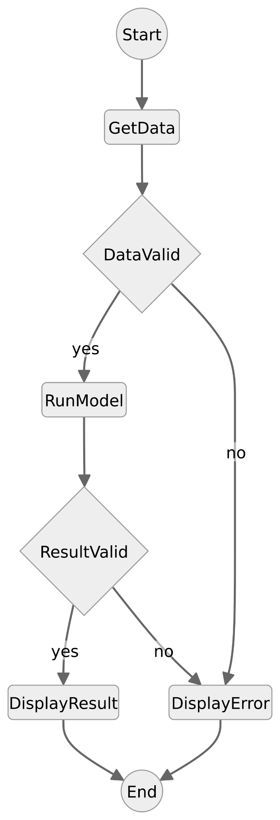

**2.4.2 DFD(Level - 0)**

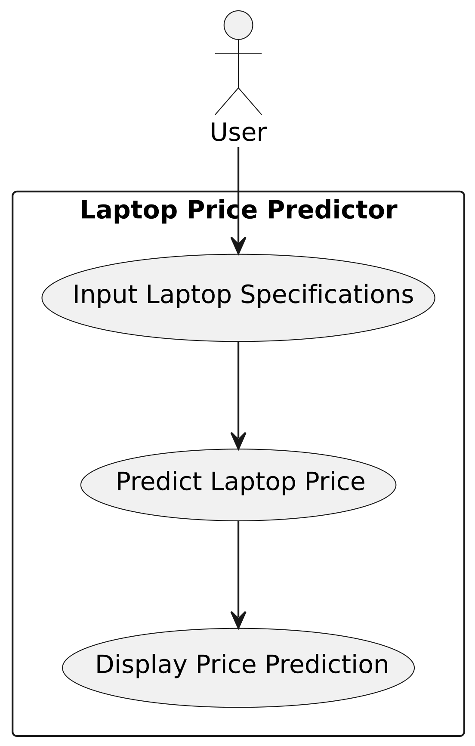

**2.4.3 DFD(Level - 1)**

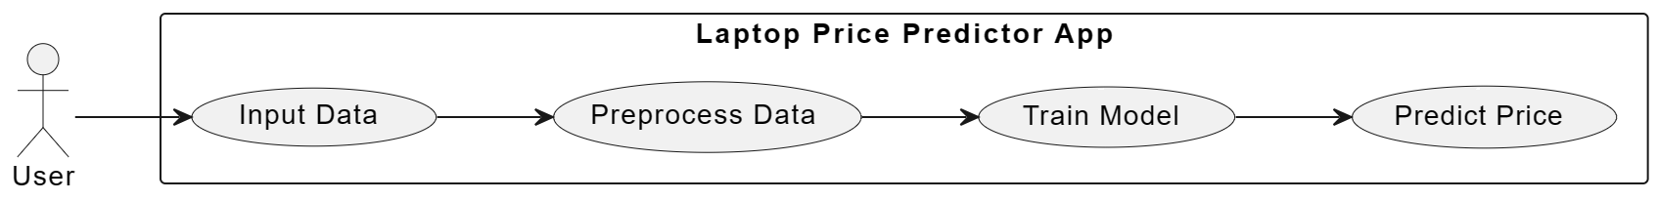

**2.4.4 DFD(Level - 2)**



**2.4.5 Use Case Diagram**

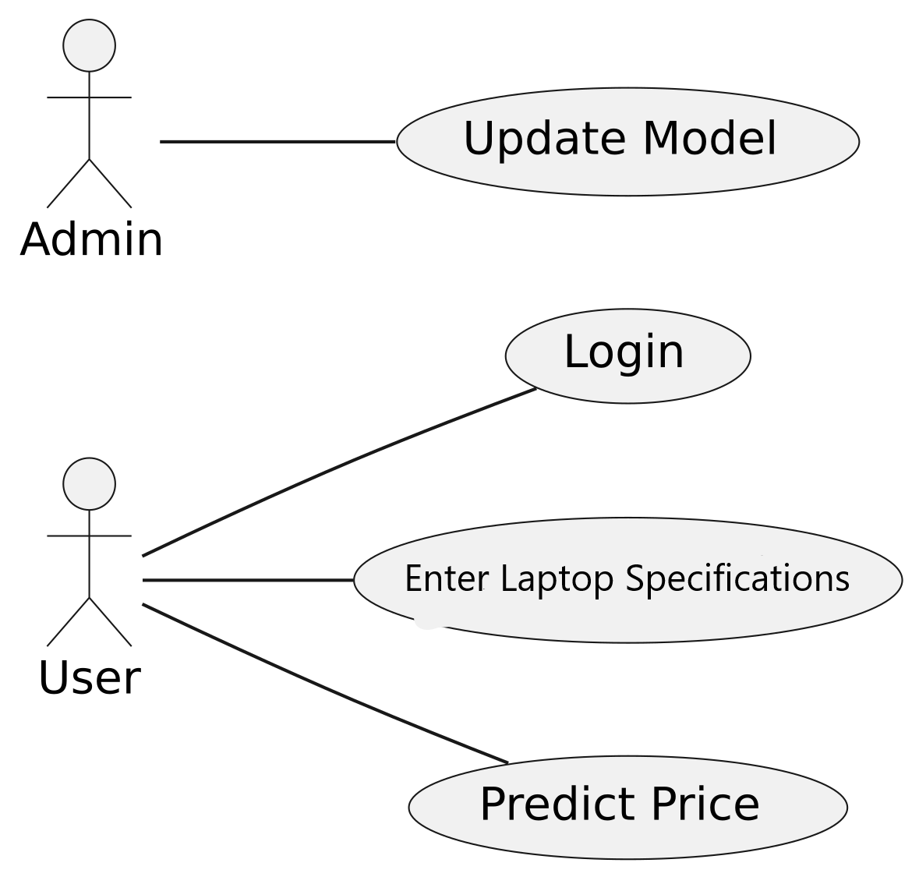

**2.4.6 Sequence Diagram**

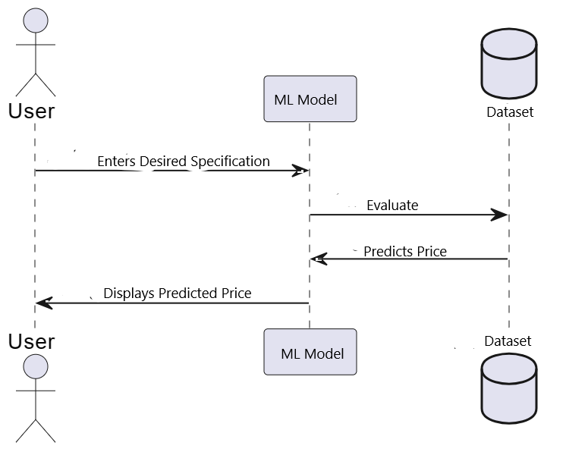

**3.1 Data Collection**: - Gather relevant data sources containing information about laptops, including features, specifications, prices, and brand reputation. This data may be obtained from online retailers, manufacturers, or other reliable sources.

In this we have used a dataset that contained information of various laptops with their specifications, brands and prices.

The snippet to the dataset is:

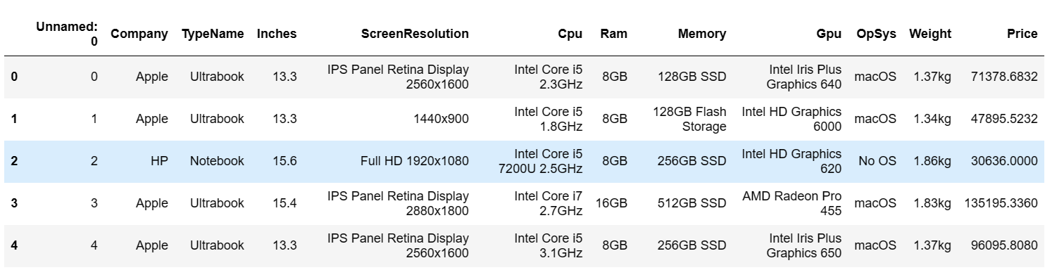

**3.2 Data Preprocessing/Cleaning and Exploratory Data Analysis (EDA)**

**3.2.1** **Data Cleaning**:

- **Handling Missing Values** - Identify and handle missing values in the dataset. This may involve imputation techniques such as replacing missing values with the mean, median, or mode of the respective feature, or using more advanced methods like predictive modeling.

- **Removing Outliers** - Detects and removes outliers that may skew the analysis or model training. Outliers can be identified using statistical methods like z-score, or by visual inspection using box plots or scatter plots.

- **Dealing with Duplicate Entries** - Check for and remove any duplicate entries in the dataset to avoid redundancy and ensure data integrity.

- **Data Transformation** - Convert categorical variables into numerical equivalents using techniques such as one-hot encoding or label encoding, as machine learning models typically require numerical input.

- **Normalization/Standardization** - Scale numerical features to a similar range to prevent features with larger magnitudes from dominating the model training process. Common techniques include min-max scaling or z-score standardization.

After preprocessing, the dataset looks like:

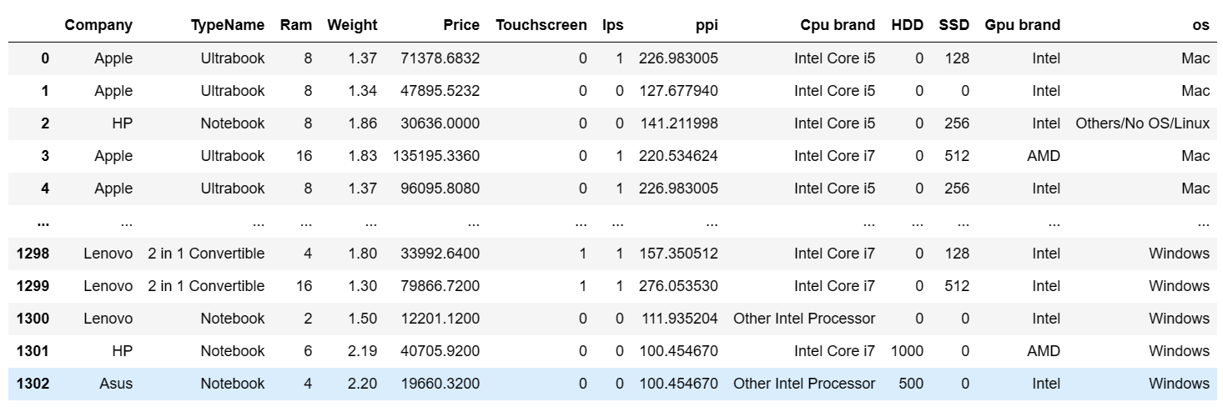

**3.2.2** **Exploratory Data Analysis (EDA)**

- **Summary Statistics** - Compute summary statistics (mean, median, mode, standard deviation, etc.) for numerical features to gain insights into their distribution and central tendency.

- **Visualization** - Create visualizations such as histograms, box plots, and scatter plots to explore the distribution of numerical features, identify patterns, correlations, and potential relationships between features and the target variable (laptop price).

- **Correlation Analysis -** Compute correlation coefficients between numerical features and the target variable to identify potentially influential features. Visualize correlations using heatmaps to understand feature interdependencies.

- **Feature Engineering** - Explore possibilities for feature engineering by creating new features or transforming existing ones based on domain knowledge or insights gained from the EDA process. This could include combining features, creating interaction terms, or extracting relevant information from text data (if applicable).

- **Outlier Detection** - Revisit outlier detection after data cleaning to ensure that outliers have been effectively addressed. Visualize outliers and assess their impact on the dataset and potential model performance.

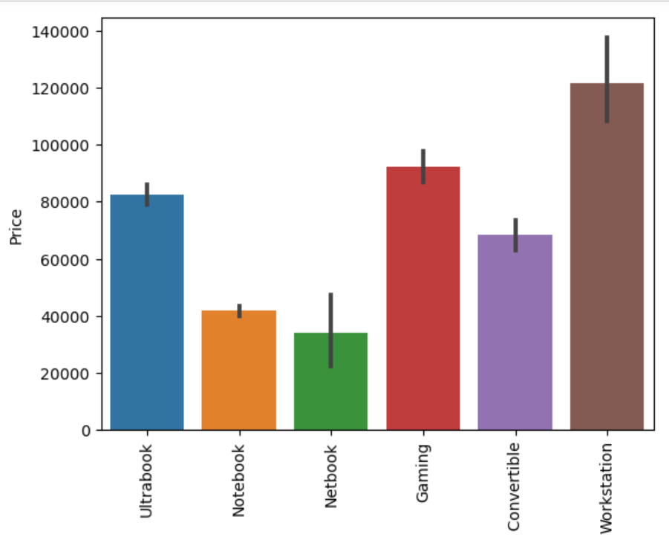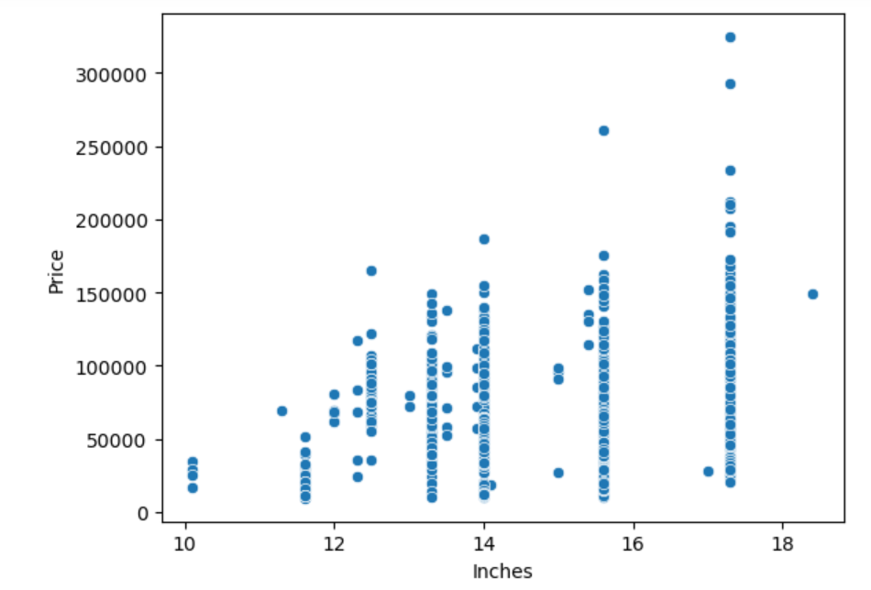

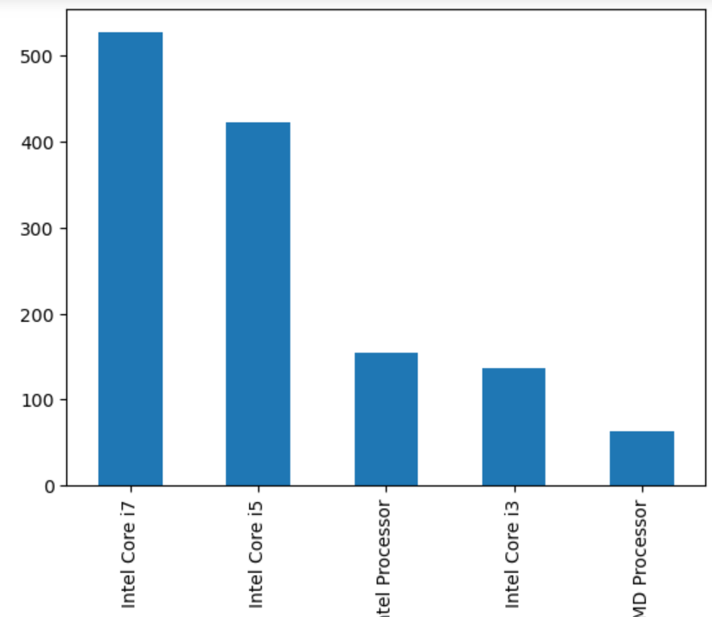

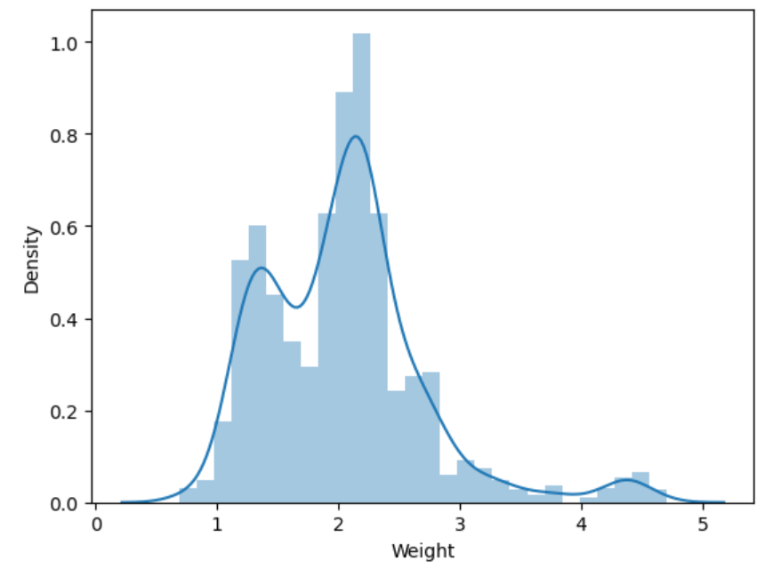

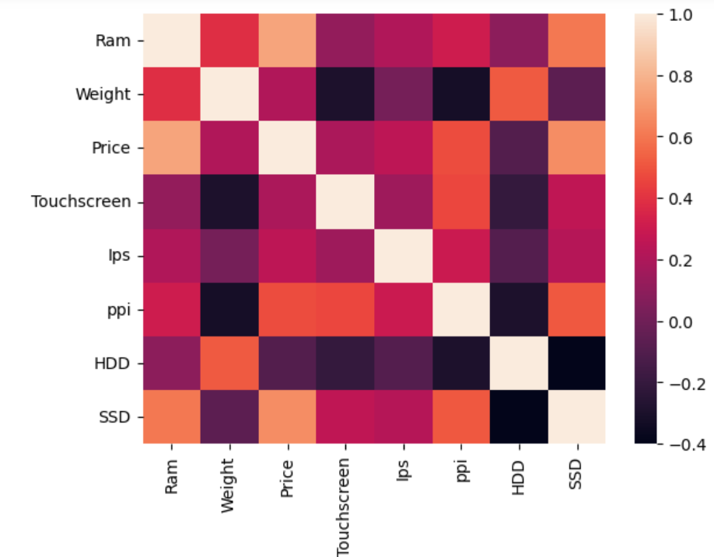

**4.1 Implementation -** Coding/Development

**4.2.1 Feature Selection**:

* Select the most relevant features that have the most significant impact on predicting laptop prices.
* Use techniques such as correlation analysis, feature importance ranking, or domain knowledge to guide feature selection.

**4.2.2 Model Selection and Training**:

* Choose appropriate machine learning algorithms for regression tasks, considering factors such as model complexity, interpretability, and performance.
* Split the data into training and testing sets for model evaluation.
* Train the selected models using the training data, tuning hyperparameters as necessary to optimize performance.

**4.2.3 Model Evaluation**:

* Evaluate the trained models using appropriate evaluation metrics such as mean absolute error (MAE), mean squared error (MSE), or R-squared.
* Compare the performance of different models to select the best-performing one.

**4.2.4 Model Deployment**:

* Deploy the trained model into a production environment where it can be accessed and used to make predictions.
* Implement necessary APIs or interfaces to allow users to input laptop features and receive price predictions.

**5 Front End / UI of the Application (Sample Screenshots)**

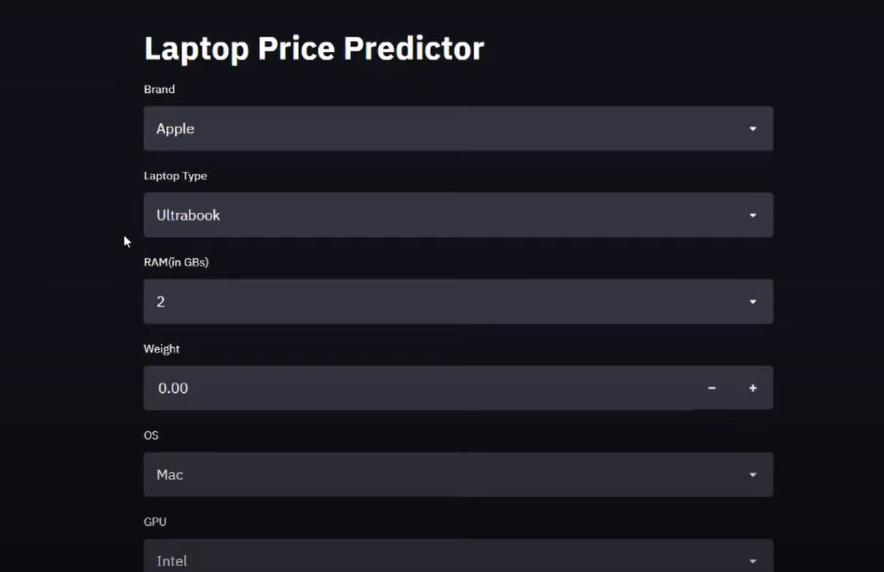

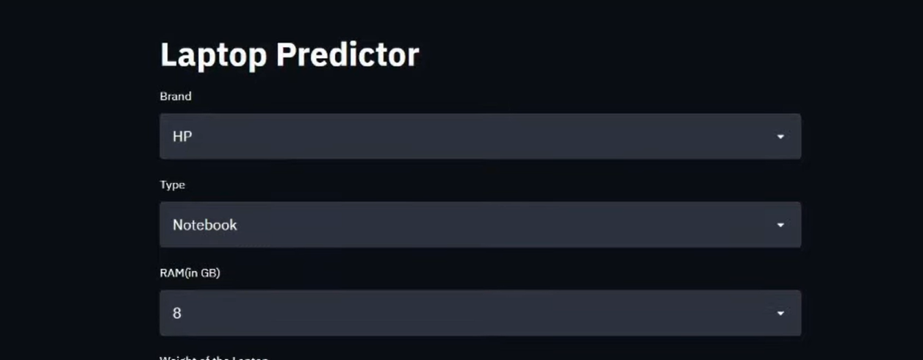

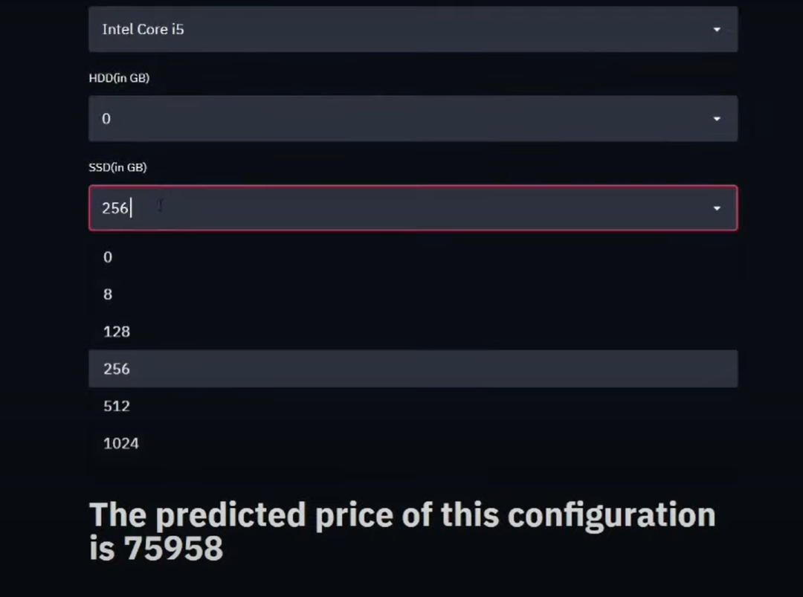

**6 Testing**

**6.1 White Box Testing -** While making the project, the actual code was tested whilst coding itself. The snippets to the same :

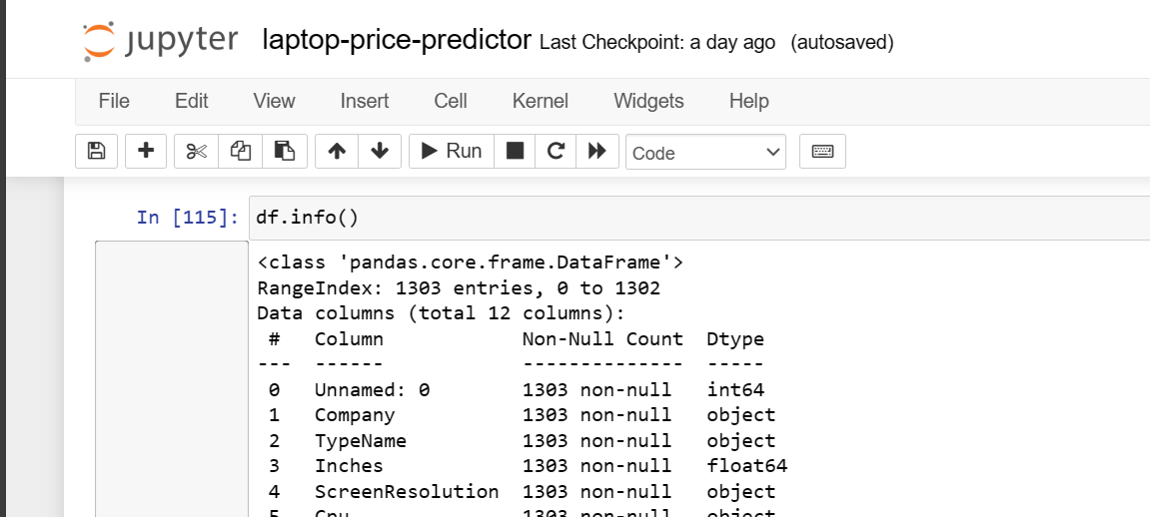

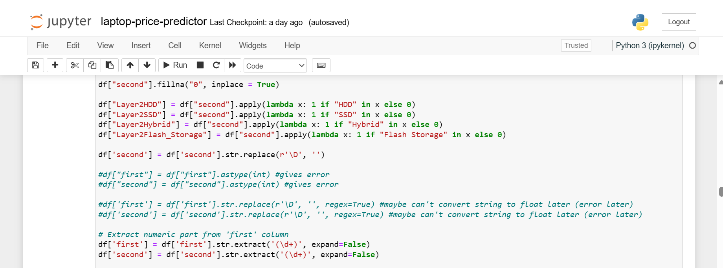

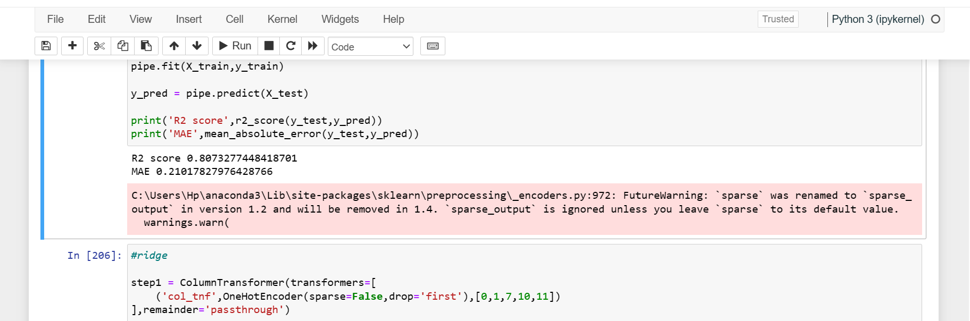

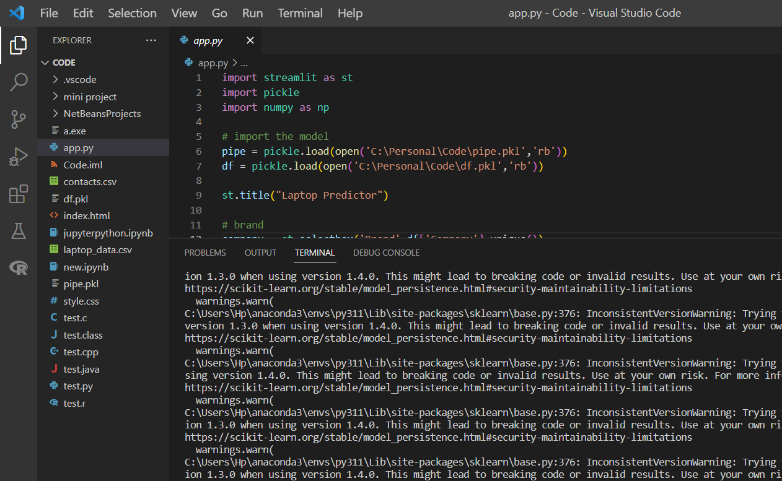

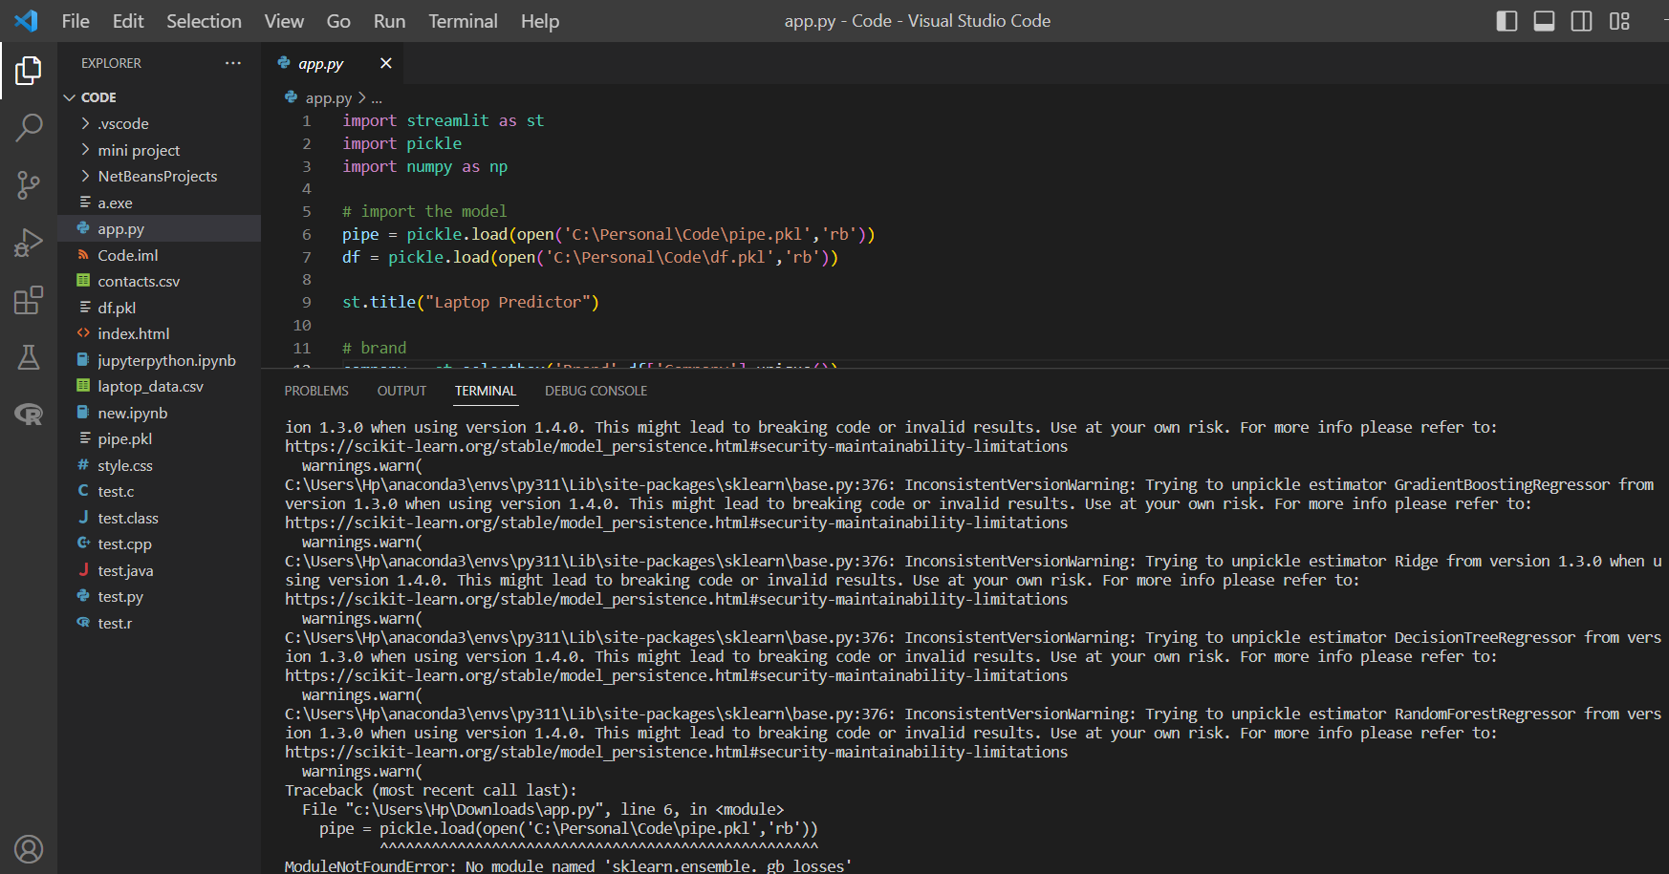

**6.2 Validation and Verification -** to check the accuracy of the model and validate the prediction of the price of the laptop, we use the already listed laptops in the e-commerce websites out there.

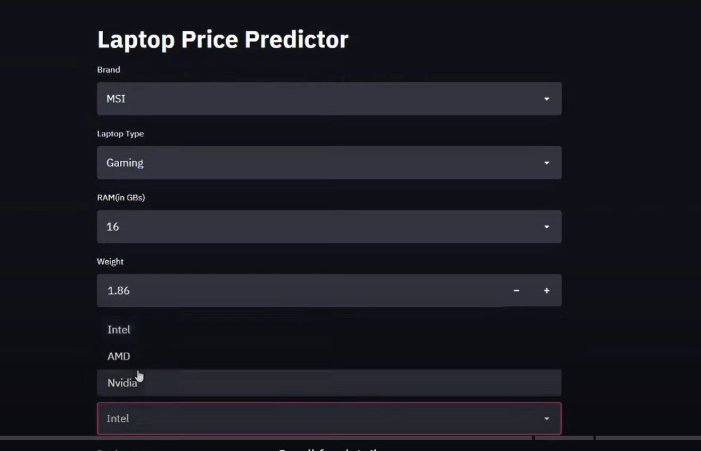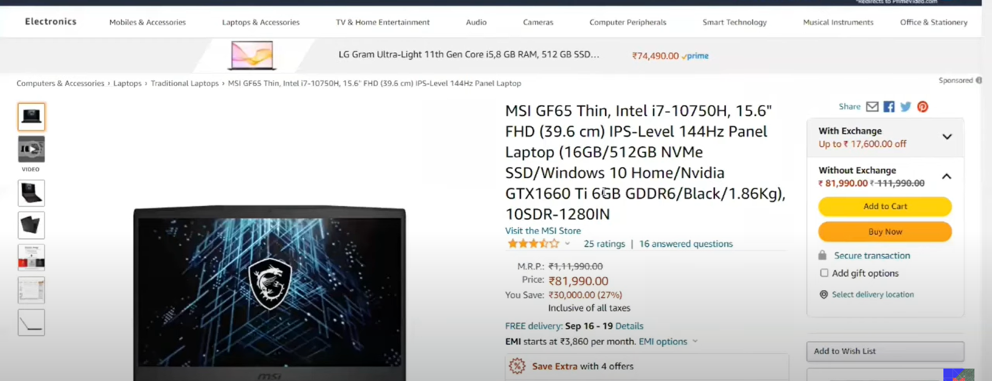

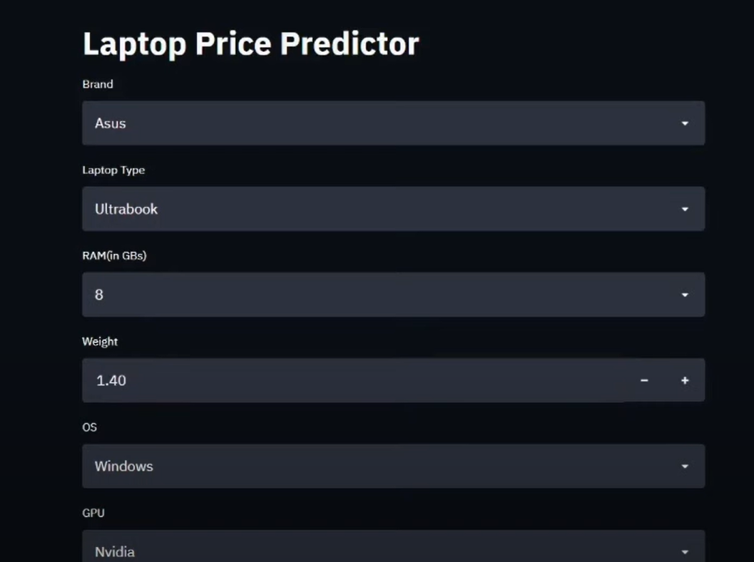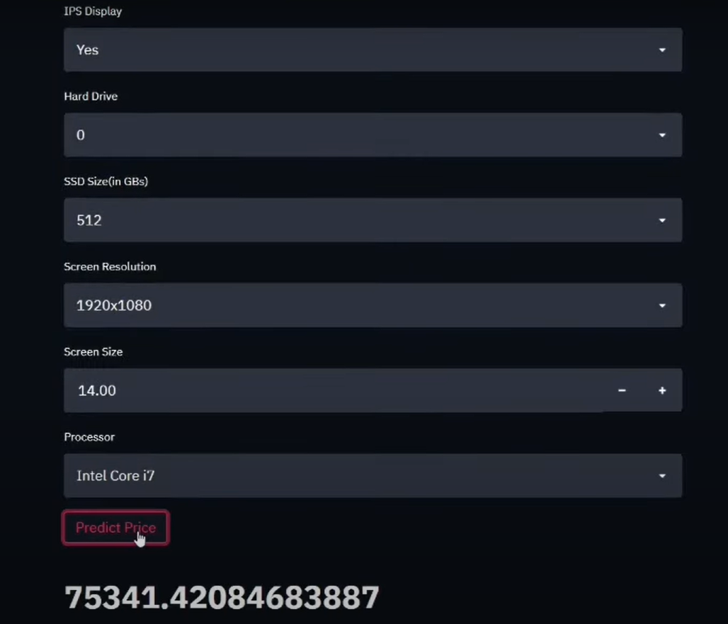

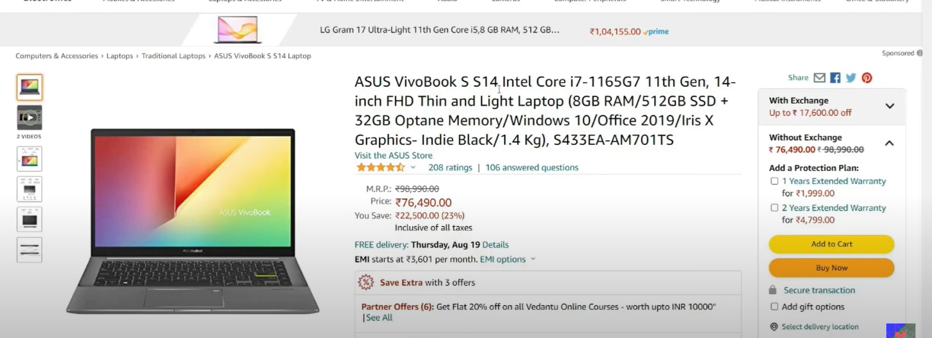

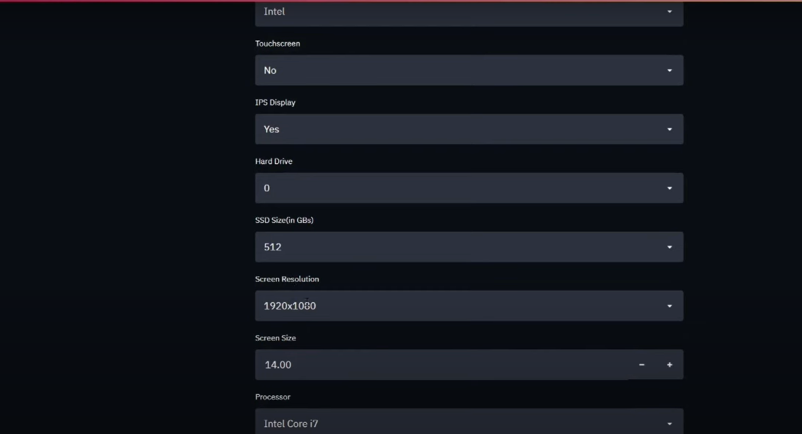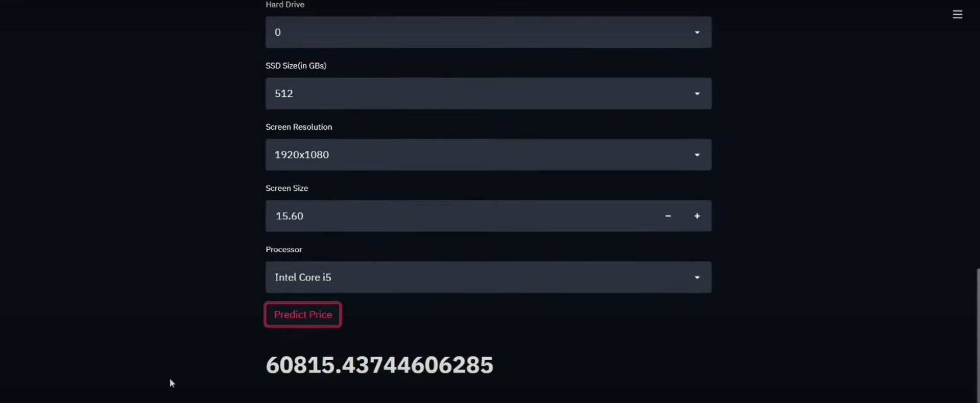

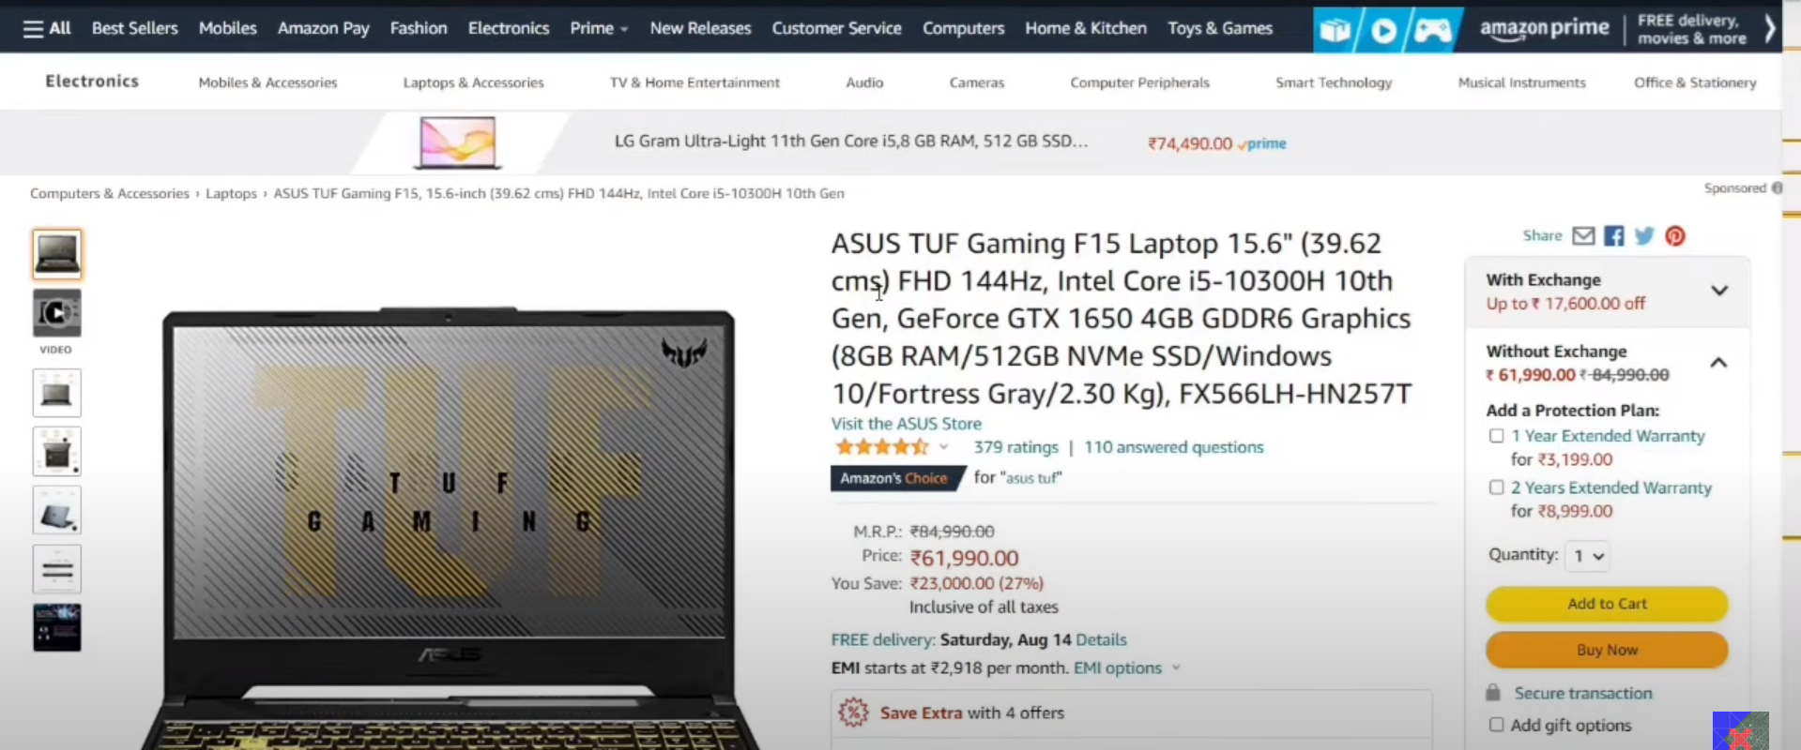

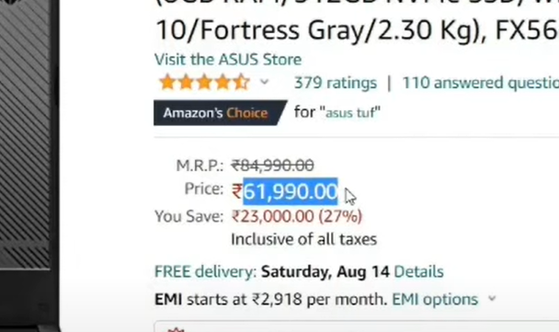

**7 Conclusion**

In conclusion, the development of a laptop price predictor offers significant potential benefits in aiding consumers and retailers alike. By leveraging machine learning algorithms trained on historical pricing data and relevant features, such as specifications and market trends, the system can accurately forecast the prices of laptops. This empowers consumers to make informed purchasing decisions based on predicted price trends, while also assisting retailers in setting competitive prices and managing inventory effectively. However, the success of such a system hinges on robust data collection, continuous model training, and adherence to stringent privacy and security measures to safeguard sensitive information. With careful implementation and refinement, a laptop price predictor has the potential to revolutionize the laptop retail industry, enhancing user satisfaction and optimizing business operations.

**7.1.1 References and Bibliography**

[www.google.com](http://www.google.com)

[www.youtube.com](http://www.youtube.com)

[www.kaggle.com](http://www.kaggle.com)

[www.github.com](http://www.github.com)

**7.1.2 Future Scope**

* Recommendations: Provide personalized recommendations to users based on their input and preferences, suggesting laptops that offer the best value for their budget and desired features.
* Market Analysis: Enable users to analyze market trends, compare prices across different brands and models, and understand how various features and specifications impact laptop prices.
* Feedback Collection: Allow users to provide feedback on the predicted prices, report any inaccuracies, and suggest improvements to the predictor's performance.
* Integration with E-commerce Platforms: Integrate with e-commerce websites or platforms to provide real-time price predictions and recommendations to users while they browse for laptops online.

**7.2 View Our Project Here** - <https://github.com/pradyumnarajnekar/temprojects/tree/main/Mini%20Project>